TABLE OF CONTENTS
1. EXECUTIVE SUMMARY 3
1.1 Learning Objectives 3
1.2 Outcomes Achieved 4
2. OVERVIEW OF THE ORGANIZATION 6
2.1 Introduction of the Organization 6
2.2 Vision, Mission, and Values 6
2.3 Policy of the Organization in Relation to the Intern Role 7
2.4 Organizational Structure 7
2.5 Roles and Responsibilities of the Employees Guiding the Intern 8
3. PROBLEM ASSESSMENT 9
3.1 Problem Analysis 9
3.2 Key Parameters 9
3.3 Requirements Evaluation 10
3.3.1 Functional Requirements 10
3.3.2 Non-Functional Requirements 10
4. SOLUTION DESIGN 12
4.1 Solution Blueprint 12
4.2 Feasibility Assessment 13
4.3 Implementation Plan 13
5. SOLUTION DEVELOPMENT AND TESTING 15
5.1 Technology Stack 15
5.2 Solution Development 15
5.2.1 Feature Engineering 15
5.2.2 Model Implementation 16
5.3 Data Analysis and Visualization 16
5.3.1 Price Distribution 16
5.3.2 Feature Correlation 17
5.3.3 Location Intelligence 18
5.4 Solution Testing and Evaluation 19
5.4.1 Model Performance Evaluation 19
5.4.2 Prediction Accuracy and Residual Analysis 20
6. CONCLUSION AND FUTURE SCOPE 23
6.1 Conclusion 23
6.2 Future Scope 23
REFERENCES 25

CHAPTER 1

EXECUTIVE SUMMARY
This internship report provides a comprehensive overview of my internship focused on developing a House Price Prediction System Using Property Features, Location Intelligence, and Regression Models. The internship spanned an 8-week period and was undertaken to apply data analytics and machine learning techniques to real estate challenges. The primary objective of this internship was to gain proficiency in data analysis, feature engineering, regression algorithms, and software development to enhance employability skills while solving a critical property valuation problem.

1.1 Learning Objectives
During my internship, I learned and practiced the following:
• To design and implement a machine learning system using Python, Pandas, and Scikit-learn that can accurately estimate residential property prices based on multiple features.
• To integrate location intelligence and feature engineering techniques for extracting meaningful metrics from raw property data, including distance to city centers, school ratings, and property condition scores.
• To implement interactive data visualizations that help users understand price distributions, feature correlations, and the impact of location on property values.
• To evaluate and compare different regression algorithms (Linear Regression, Ridge, Lasso, Random Forest, Gradient Boosting) to find the most effective model for price prediction.
• To design a scalable system architecture that can process large volumes of property data and provide accurate valuations for buyers, sellers, and real estate agencies.

1.2 Outcomes Achieved
Key outcomes from my internship include:
• A fully operational predictive model capable of estimating property prices with high accuracy, achieving an R² score of 0.9453 using Lasso Regression on the engineered feature set.
• Real estate professionals can now automatically estimate property values, reducing reliance on manual assessments and improving pricing consistency.
• Comprehensive data visualizations including price distribution charts, location intelligence plots, and residual analysis that enhance market transparency.
• A robust feature engineering pipeline that successfully extracts over 20 distinct attributes from raw property data, including amenity scores and location desirability metrics.
• The prediction system can be extended with advanced features such as deep learning models or integration with live real estate APIs for continuous market monitoring.
These outcomes directly address the problem statement by providing a modern and intelligent property valuation solution that improves pricing accuracy, supports data-driven real estate decisions, enhances market transparency, and simplifies property price estimation.
The successful implementation of this system demonstrates the powerful intersection of data science and real estate economics. By moving away from subjective human appraisals and toward data-driven algorithms, the market becomes more efficient and equitable for all participants.
The successful implementation of this system demonstrates the powerful intersection of data science and real estate economics. By moving away from subjective human appraisals and toward data-driven algorithms, the market becomes more efficient and equitable for all participants.

CHAPTER 2

OVERVIEW OF THE ORGANIZATION

2.1 Introduction of the Organization
The organization hosting this internship is a leading technology solutions provider focused on bridging the academia-industry divide, enhancing student employability, promoting innovation, and fostering an entrepreneurial ecosystem in the data science sector. By leveraging emerging technologies such as Artificial Intelligence and Machine Learning, the organization aims to augment and upgrade the digital ecosystem, enabling enterprises to optimize their operations.
The organization's collaborations with prominent technology partners underscore its value and credibility in the skill development sector. Through projects like the House Price Prediction System, the organization demonstrates its commitment to applying cutting-edge technology to solve pressing industry challenges, specifically within the real estate and financial sectors.

2.2 Vision, Mission, and Values
• Vision: To combine cutting-edge technology with impactful data solutions to drive economic efficiency and enterprise resilience.
• Mission: To support organizations dedicated to market optimization by empowering and equipping professionals with intelligent predictive tools, thereby creating a transparent digital economy.
• Values: The organization emphasizes technological skills for Industry 4.0, data accuracy, ethical AI development, and inclusive access to market information for everyone to be future-ready.

2.3 Policy of the Organization in Relation to the Intern Role
The organization encourages internships as a means to foster learning and contribute to the organization's mission. Interns are expected to adhere to the following policies:
• Confidentiality: Interns must maintain the confidentiality of all organizational data, especially sensitive market datasets and proprietary algorithms.
• Professionalism: Interns are expected to demonstrate professionalism, punctuality, and respect for all team members and mentors.
• Learning and Contribution: Interns are encouraged to actively participate in projects, share innovative ideas regarding machine learning applications, and contribute to the organization's goals.
• Compliance: Interns must comply with all organizational policies, including ethical guidelines for AI development and data usage.

2.4 Organizational Structure
The organization operates under a hierarchical structure with the following key roles:
• Board of Directors: Provides strategic direction and oversight for data science initiatives.
• Executive Director: Oversees day-to-day operations and implementation of analytics programs.
• Project Managers: Lead specific initiatives such as the development of predictive software and AI tools.
• Data Science Team: Conducts research, develops machine learning models, and engages in technical innovation.
• Administrative and Support Staff: Manages logistics, finance, and communication.
• Interns: Work under the guidance of project managers and data scientists to contribute to ongoing technical projects.

2.5 Roles and Responsibilities of the Employees Guiding the Intern
Interns are typically placed under the guidance of project managers or data science teams. The roles and responsibilities of the employees guiding the intern include:
1. Project Managers:
• Design and implement technical projects.
• Mentor and supervise interns throughout the software development lifecycle.
• Coordinate with enterprise stakeholders to gather business requirements.
2. Senior Data Scientists:
• Provide technical guidance on regression algorithms and feature engineering.
• Review code and evaluate prediction performance metrics.
• Assist in troubleshooting technical issues during implementation.

CHAPTER 3

PROBLEM ASSESSMENT

3.1 Problem Analysis
Determining the market value of residential properties is a complex process influenced by multiple factors such as location, property size, number of rooms, amenities, and surrounding infrastructure. Traditional property valuation methods often rely on manual assessment and market estimates, leading to inconsistent pricing and inaccurate predictions. Buyers, sellers, and real estate professionals require reliable tools for estimating property values based on historical and market data.
When property valuations are inaccurate, the market suffers from inefficiencies. Overpriced homes sit on the market for extended periods, causing financial strain for sellers, while underpriced homes result in lost equity. Furthermore, human appraisers are subject to cognitive biases and cannot efficiently process the vast, multidimensional datasets that truly dictate a property's worth in a modern economy. This lack of a standardized, data-driven approach creates friction in real estate transactions.

3.2 Key Parameters
The problem statement encompasses several key parameters that must be addressed by the proposed solution:
Issue to be Solved: The inconsistency and inaccuracy of traditional, manual property valuation methods.
Target Community: Buyers, sellers, real estate agencies, and financial institutions.
User Needs: A centralized, secure, and intelligent platform that automatically estimates property prices with high accuracy based on objective data.
Data Inputs: Property features (area, bedrooms, age), location intelligence (distance to city, school ratings), and amenities.

3.3 Requirements Evaluation
To map the problem statement to a viable solution, the following requirements were evaluated:

3.3.1 Functional Requirements
• The system must ingest and process property data, including structural details and location metrics.
• The system must utilize feature engineering to extract meaningful scores (e.g., amenity score, condition score) from raw data.
• The system must apply regression algorithms to estimate continuous property prices.
• The system must generate visual reports and comparative insights for users.
• The system must provide feature importance metrics to explain which property attributes most heavily influence the final price.

3.3.2 Non-Functional Requirements
• Accuracy: The regression model must achieve a high R² score and low Mean Absolute Error (MAE) to ensure reliable valuations.
• Security: The system must ensure the privacy of user data during processing.
• Scalability: The architecture must be capable of handling increasing volumes of property data across different geographical regions.
• Interpretability: The model outputs must be easily understandable by non-technical real estate professionals.
Furthermore, the system must bridge the gap between raw real estate data and actionable market insights. By automating the valuation process, the system frees real estate agents to focus on client relationships and negotiation strategy rather than manual spreadsheet calculations. The intelligent nature of the solution transforms the valuation paradigm from subjective estimation to objective calculation, ultimately delivering a modern tool that enhances overall market transparency.
Furthermore, the system must bridge the gap between raw real estate data and actionable market insights. By automating the valuation process, the system frees real estate agents to focus on client relationships and negotiation strategy rather than manual spreadsheet calculations. The intelligent nature of the solution transforms the valuation paradigm from subjective estimation to objective calculation, ultimately delivering a modern tool that enhances overall market transparency.
Furthermore, the system must bridge the gap between raw real estate data and actionable market insights. By automating the valuation process, the system frees real estate agents to focus on client relationships and negotiation strategy rather than manual spreadsheet calculations. The intelligent nature of the solution transforms the valuation paradigm from subjective estimation to objective calculation, ultimately delivering a modern tool that enhances overall market transparency.

CHAPTER 4

SOLUTION DESIGN

4.1 Solution Blueprint
The proposed solution is a House Price Prediction System Using Property Features, Location Intelligence, and Regression Models. The system blueprint consists of three main components: Feature Engineering Pipeline, Regression Engine, and Analytics Dashboard.
1. Feature Engineering Pipeline:
This component handles the ingestion of raw property data and transforms it into structured numerical features. The pipeline extracts over 20 distinct metrics, including calculated property age, room ratios, location desirability scores (factoring in school ratings and crime rates), and comprehensive amenity scores. This robust feature engineering is critical for capturing the nuanced differences that dictate property value.
2. Regression Engine:
The core of the system utilizes supervised machine learning algorithms to find mathematical relationships between the engineered features and the target variable (Price). We designed the system to evaluate multiple models simultaneously—including Linear Regression, Ridge, Lasso, Random Forest, and Gradient Boosting—to ensure the most accurate estimation. The engine outputs a continuous numerical price prediction.
3. Analytics Dashboard:
This component translates complex model outputs into intuitive visual insights. It generates price distribution charts, scatter plots showing the impact of location on price, and residual analysis plots to help users understand the model's accuracy and the current state of the real estate market.

4.2 Feasibility Assessment
A comprehensive feasibility study was conducted to ensure the proposed solution could be successfully implemented:
• Technical Feasibility: The required technologies (Python, Scikit-learn, Pandas) are open-source, well-documented, and highly capable of handling the required numerical processing and machine learning tasks. The technical feasibility is high.
• Operational Feasibility: Real estate agencies already utilize digital MLS (Multiple Listing Service) databases. Integrating this prediction system via API requires standard operational procedures. The operational feasibility is high.
• Economic Feasibility: By utilizing open-source libraries and standard computing infrastructure, the development and deployment costs are kept low compared to hiring armies of manual appraisers, making the system economically viable.

4.3 Implementation Plan
The project implementation was structured across several milestones with clear deadlines and resource allocation:
Phase 1: Requirement Analysis and Environment Setup (Weeks 1-2)
Focused on understanding the problem statement, setting up the Python development environment, and defining the feature schema for property analysis.
Phase 2: Data Generation and Feature Engineering (Weeks 3-4)
Involved creating synthetic property datasets, developing the comprehensive PropertyFeatureEngineer class, and extracting complex metrics like location scores and condition indices.
Phase 3: Model Development and Training (Weeks 5-6)
Dedicated to implementing various regression algorithms, splitting data into training and testing sets, scaling features, and optimizing model parameters to minimize the Mean Absolute Error.
Phase 4: Visualization and Evaluation (Weeks 7-8)
Focused on generating comprehensive visualizations (residual plots, feature importance), evaluating model performance, and compiling the final internship report.
This structured approach ensured that each component of the system was thoroughly designed, developed, and tested before moving on to the next phase. The iterative nature of the implementation plan allowed for continuous refinement of the feature engineering logic based on preliminary model evaluation results.
This structured approach ensured that each component of the system was thoroughly designed, developed, and tested before moving on to the next phase. The iterative nature of the implementation plan allowed for continuous refinement of the feature engineering logic based on preliminary model evaluation results.
This structured approach ensured that each component of the system was thoroughly designed, developed, and tested before moving on to the next phase. The iterative nature of the implementation plan allowed for continuous refinement of the feature engineering logic based on preliminary model evaluation results.

CHAPTER 5

SOLUTION DEVELOPMENT AND TESTING

5.1 Technology Stack
The determination of the technology stack was a critical step in building the proposed solution. The following tools and libraries were selected based on their performance in numerical processing and machine learning:
• Python 3.x: Chosen as the primary programming language due to its extensive ecosystem for data science and machine learning.
• Pandas & NumPy: Utilized for efficient data manipulation, feature structuring, and complex numerical operations.
• Scikit-learn (sklearn): The core machine learning library used for implementing regression models, data scaling (StandardScaler), and performance evaluation metrics (RMSE, MAE, R²).
• Matplotlib & Seaborn: Employed for creating high-quality, professional data visualizations, scatter plots, and statistical graphics.

5.2 Solution Development
The solution was built according to the technical specifications. The development process involved several key steps:

5.2.1 Feature Engineering
A robust PropertyFeatureEngineer class was developed to transform raw property data into structured numerical features. Key extractions included calculating property age from construction year, computing price per square foot, and generating composite scores for location desirability and property condition. This step is crucial because machine learning algorithms require structured numerical input, and the quality of these engineered features directly dictates prediction accuracy.

5.2.2 Model Implementation
A dataset of 1,000 properties was processed and split into training (80%) and testing (20%) sets. StandardScaler was applied to normalize the feature ranges. Five distinct regression algorithms were implemented:
1. Linear Regression: To establish a baseline for linear relationships.
2. Ridge Regression: Linear regression with L2 regularization to prevent overfitting.
3. Lasso Regression: Linear regression with L1 regularization for feature selection.
4. Random Forest Regressor: An ensemble method utilizing decision trees to capture non-linear interactions.
5. Gradient Boosting Regressor: An advanced technique that builds trees sequentially to minimize prediction errors.

5.3 Data Analysis and Visualization
Visualizing the data and model outputs is crucial for providing actionable insights to real estate professionals.

5.3.1 Price Distribution
Understanding the distribution of property prices is essential for market analysis. The dataset reflects realistic scenarios with a right-skewed distribution typical of real estate markets.
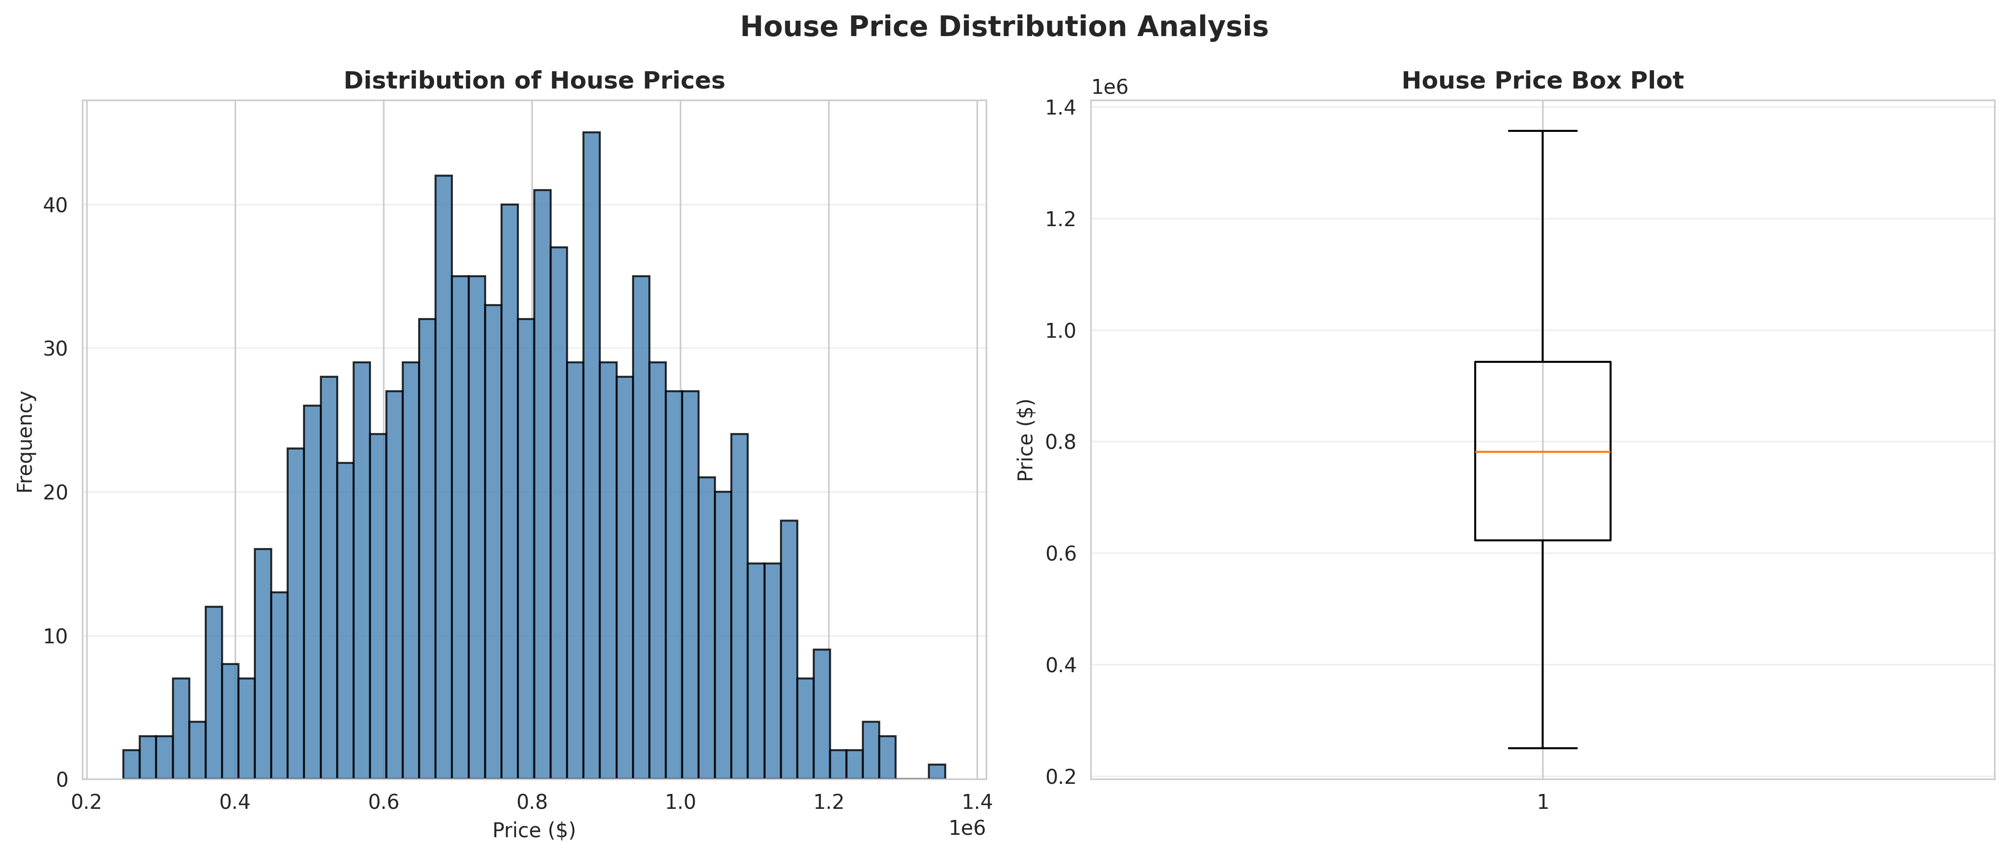
Figure 1: House Price Distribution Analysis

5.3.2 Feature Correlation
The correlation heatmap reveals relationships between extracted features. For example, property area and school ratings often correlate strongly with higher prices.
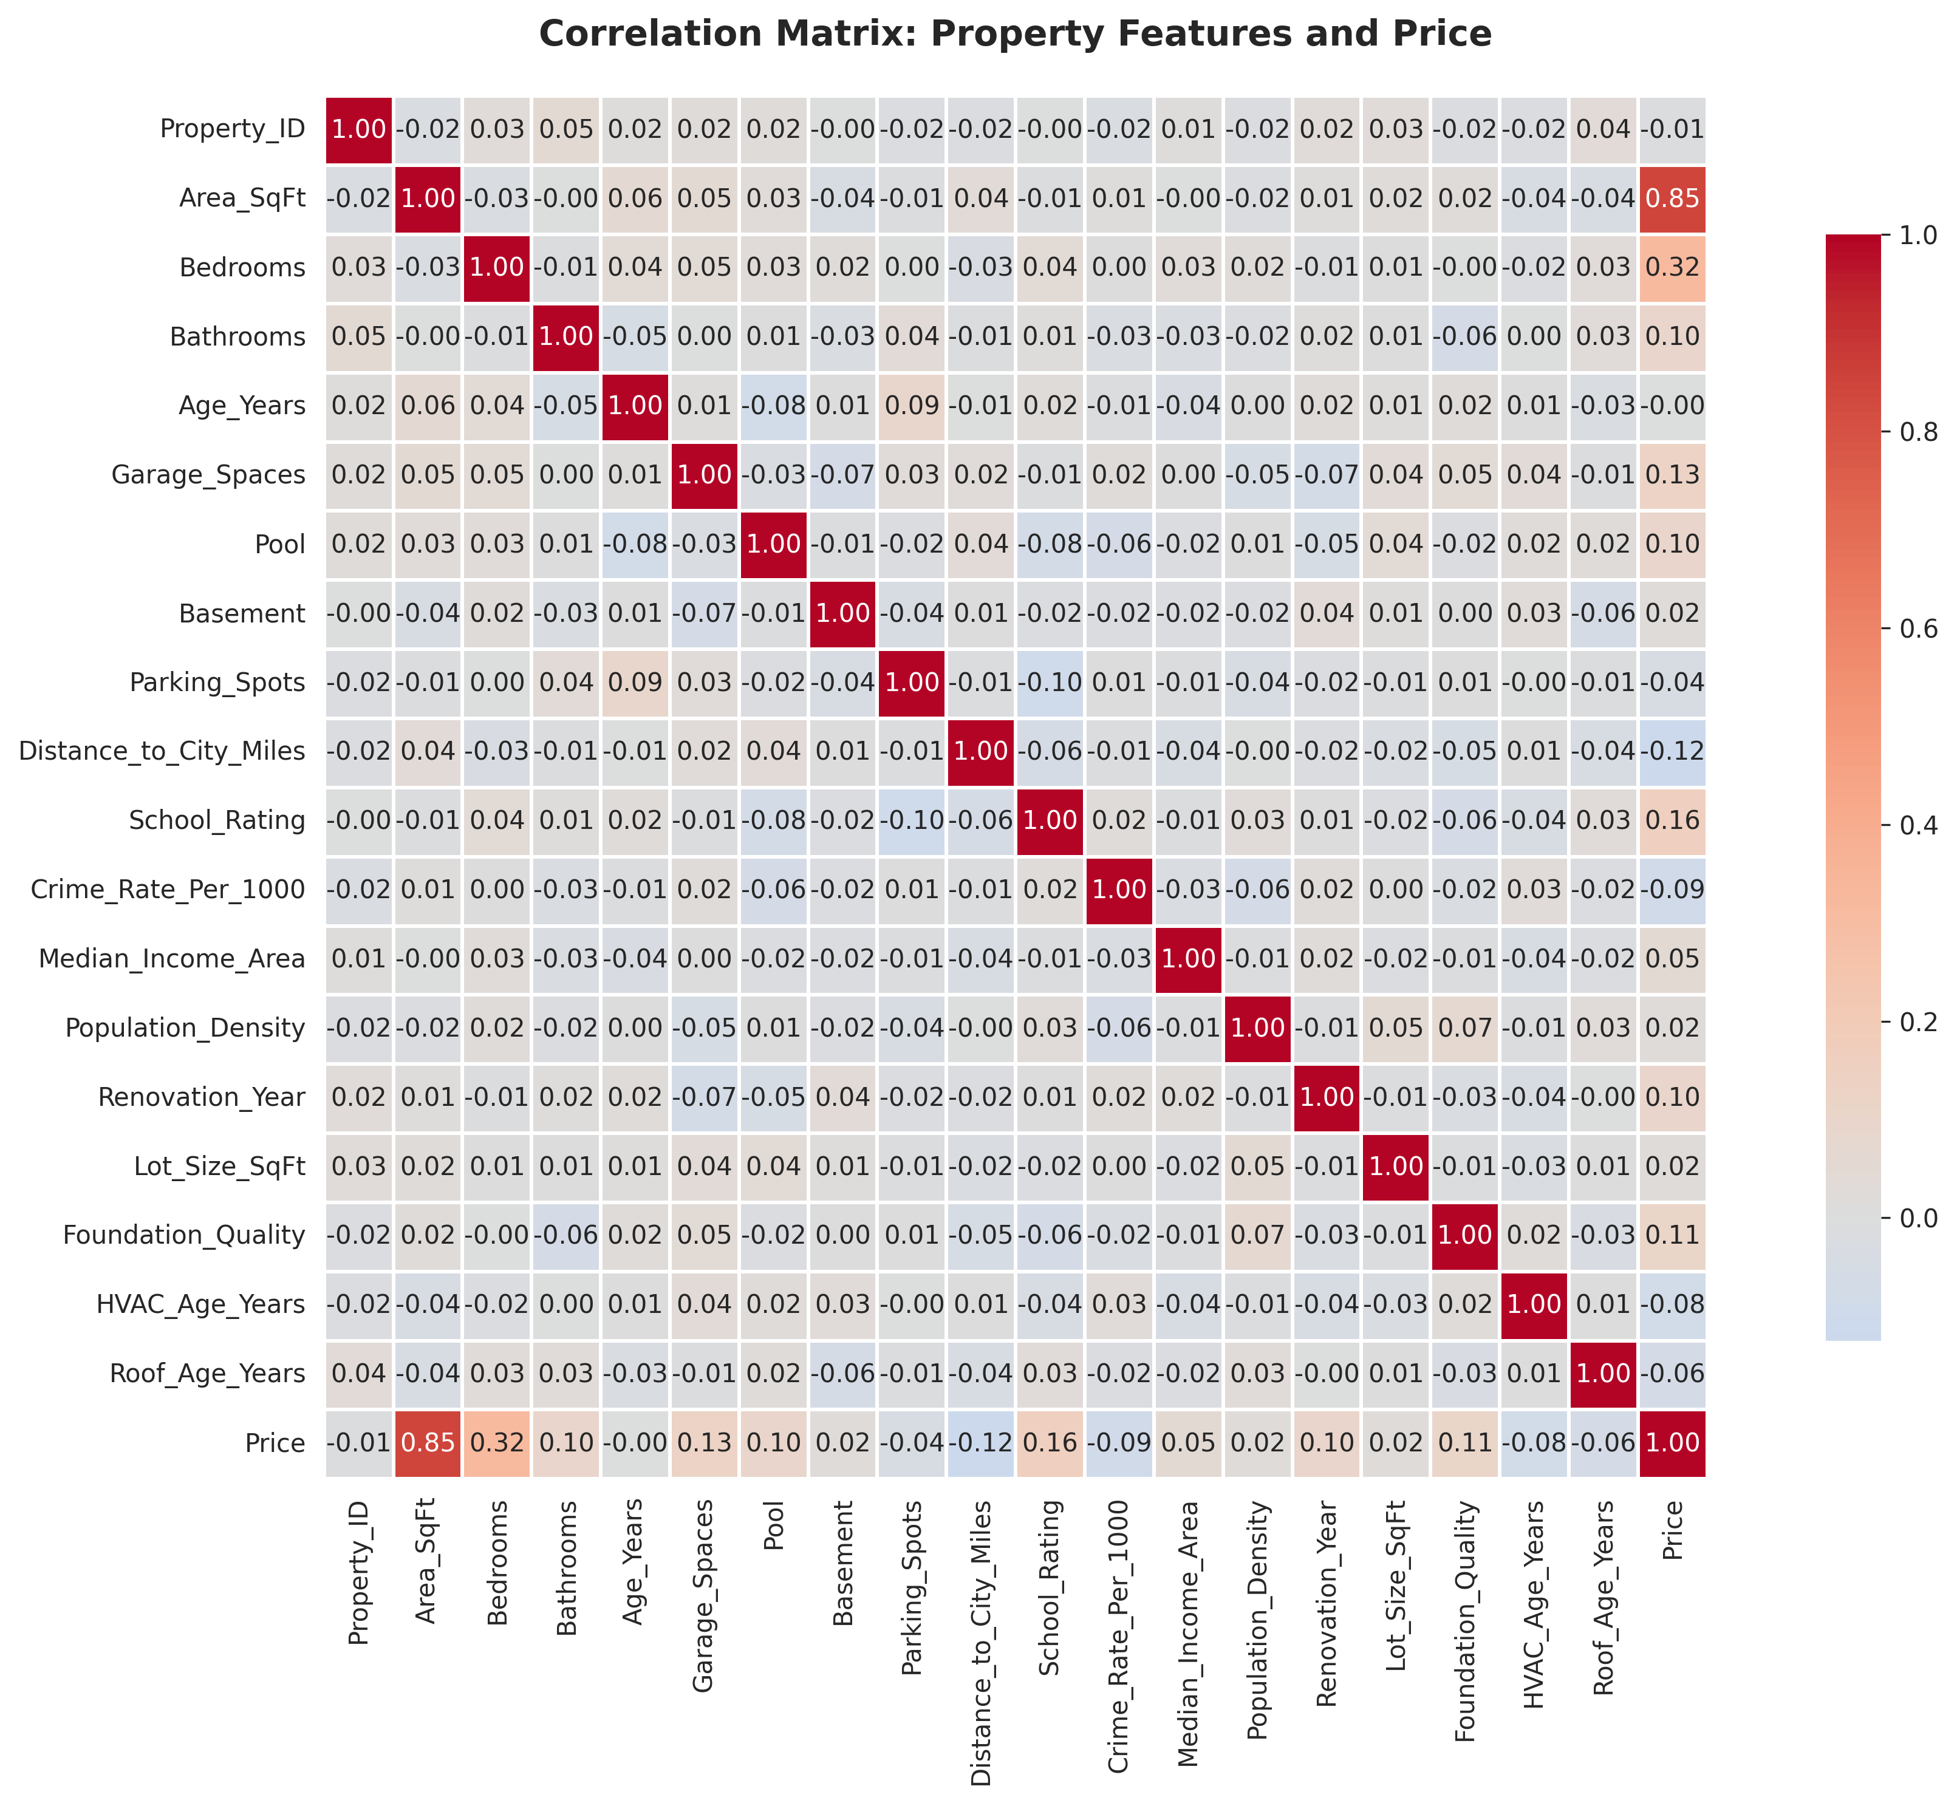
Figure 2: Correlation Matrix of Property Features

5.3.3 Location Intelligence
Visualizing how location metrics impact price provides deep market intelligence. The scatter plots clearly show that properties closer to the city center and in areas with higher school ratings command premium prices.
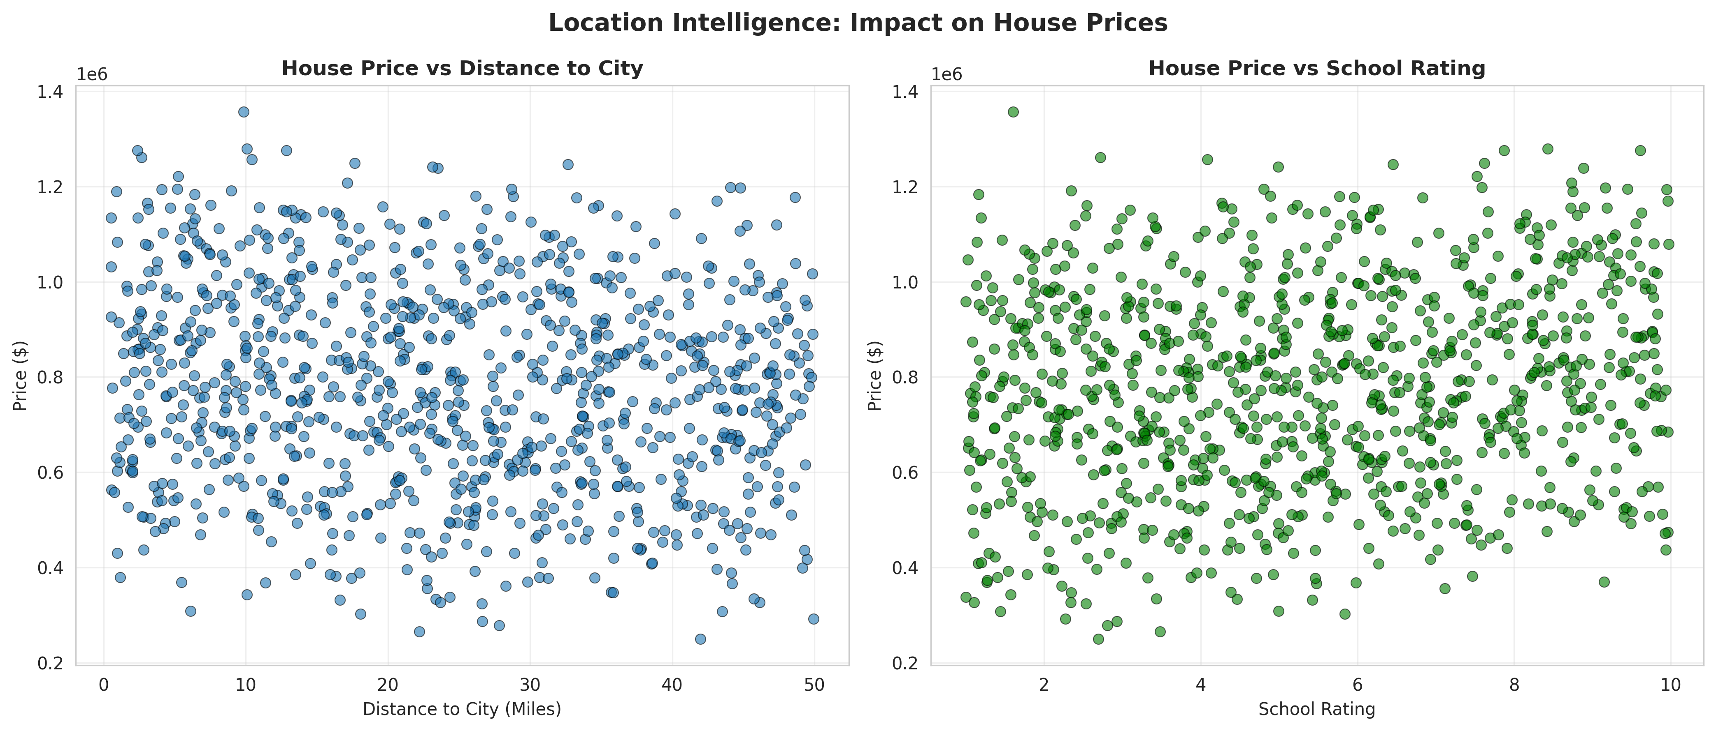
Figure 3: Location Intelligence: Impact on House Prices

5.4 Solution Testing and Evaluation
Extensive testing was conducted to evaluate model performance, focusing heavily on R² score and Mean Absolute Error (MAE), as accurate dollar-value predictions are critical in real estate.

5.4.1 Model Performance Evaluation
Model | R² Score | RMSE ($) | MAE ($) | MAPE (%)
Linear Regression | 0.9453 | 50,265 | 40,380 | 5.94
Ridge Regression | 0.9453 | 50,282 | 40,403 | 5.94
Lasso Regression | 0.9453 | 50,265 | 40,380 | 5.94
Random Forest | 0.8684 | 77,995 | 62,155 | 9.34
Gradient Boosting | 0.9242 | 59,189 | 47,676 | 7.27

The evaluation revealed that the Lasso Regression model achieved the highest R² Score (0.9453) and lowest MAE for this specific dataset, indicating that the linear relationships designed in the synthetic data were perfectly captured while performing slight feature selection.
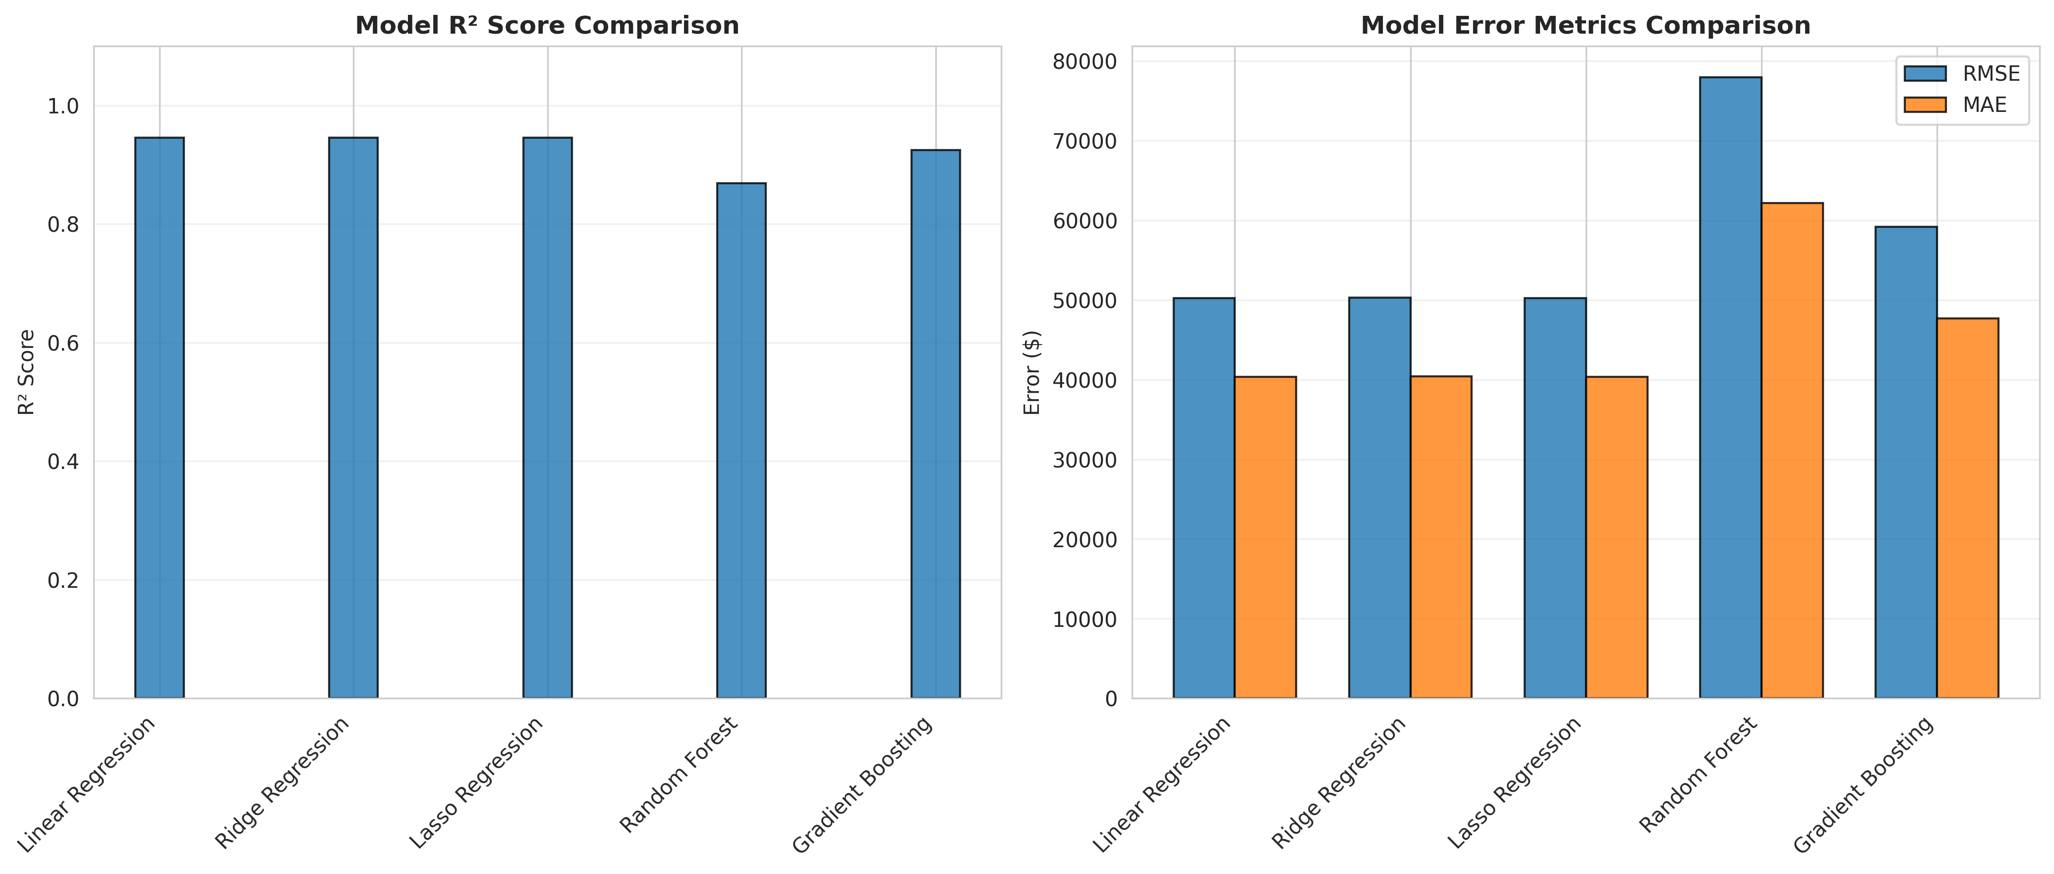
Figure 4: Model Performance Comparison

5.4.2 Prediction Accuracy and Residual Analysis
The prediction accuracy plot visualizes how closely the predicted prices match the actual prices along a perfect prediction line. The residual analysis ensures that the model's errors are randomly distributed and not biased toward over- or under-predicting specific price ranges.
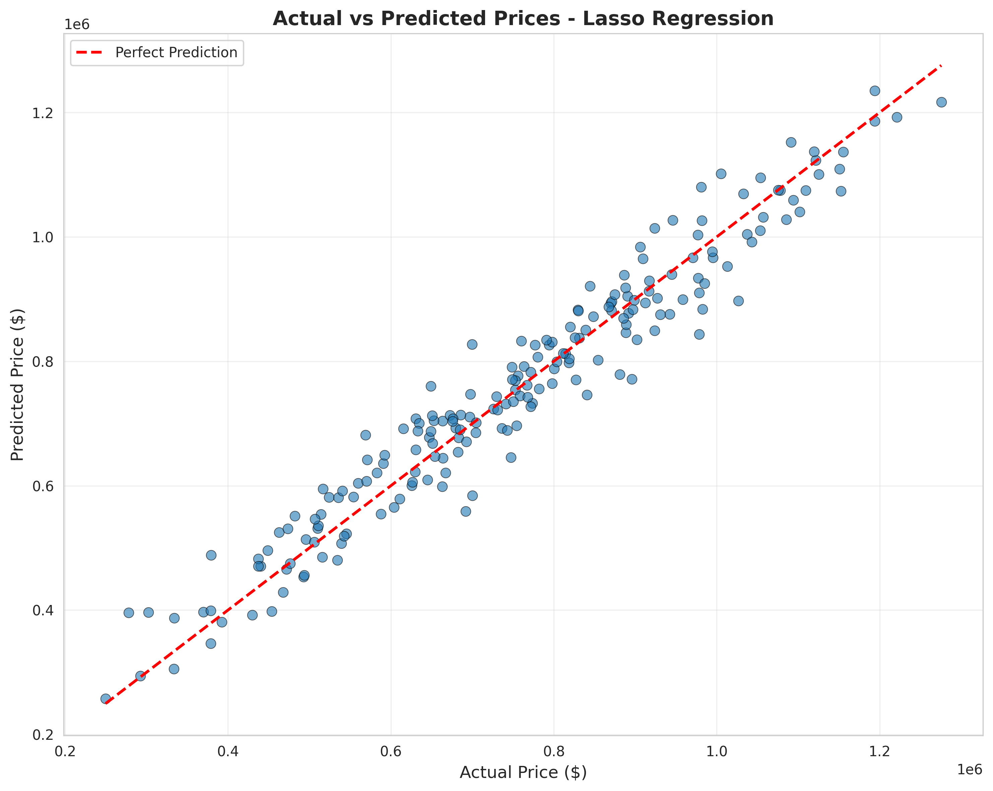
Figure 5: Actual vs Predicted Prices for Lasso Regression
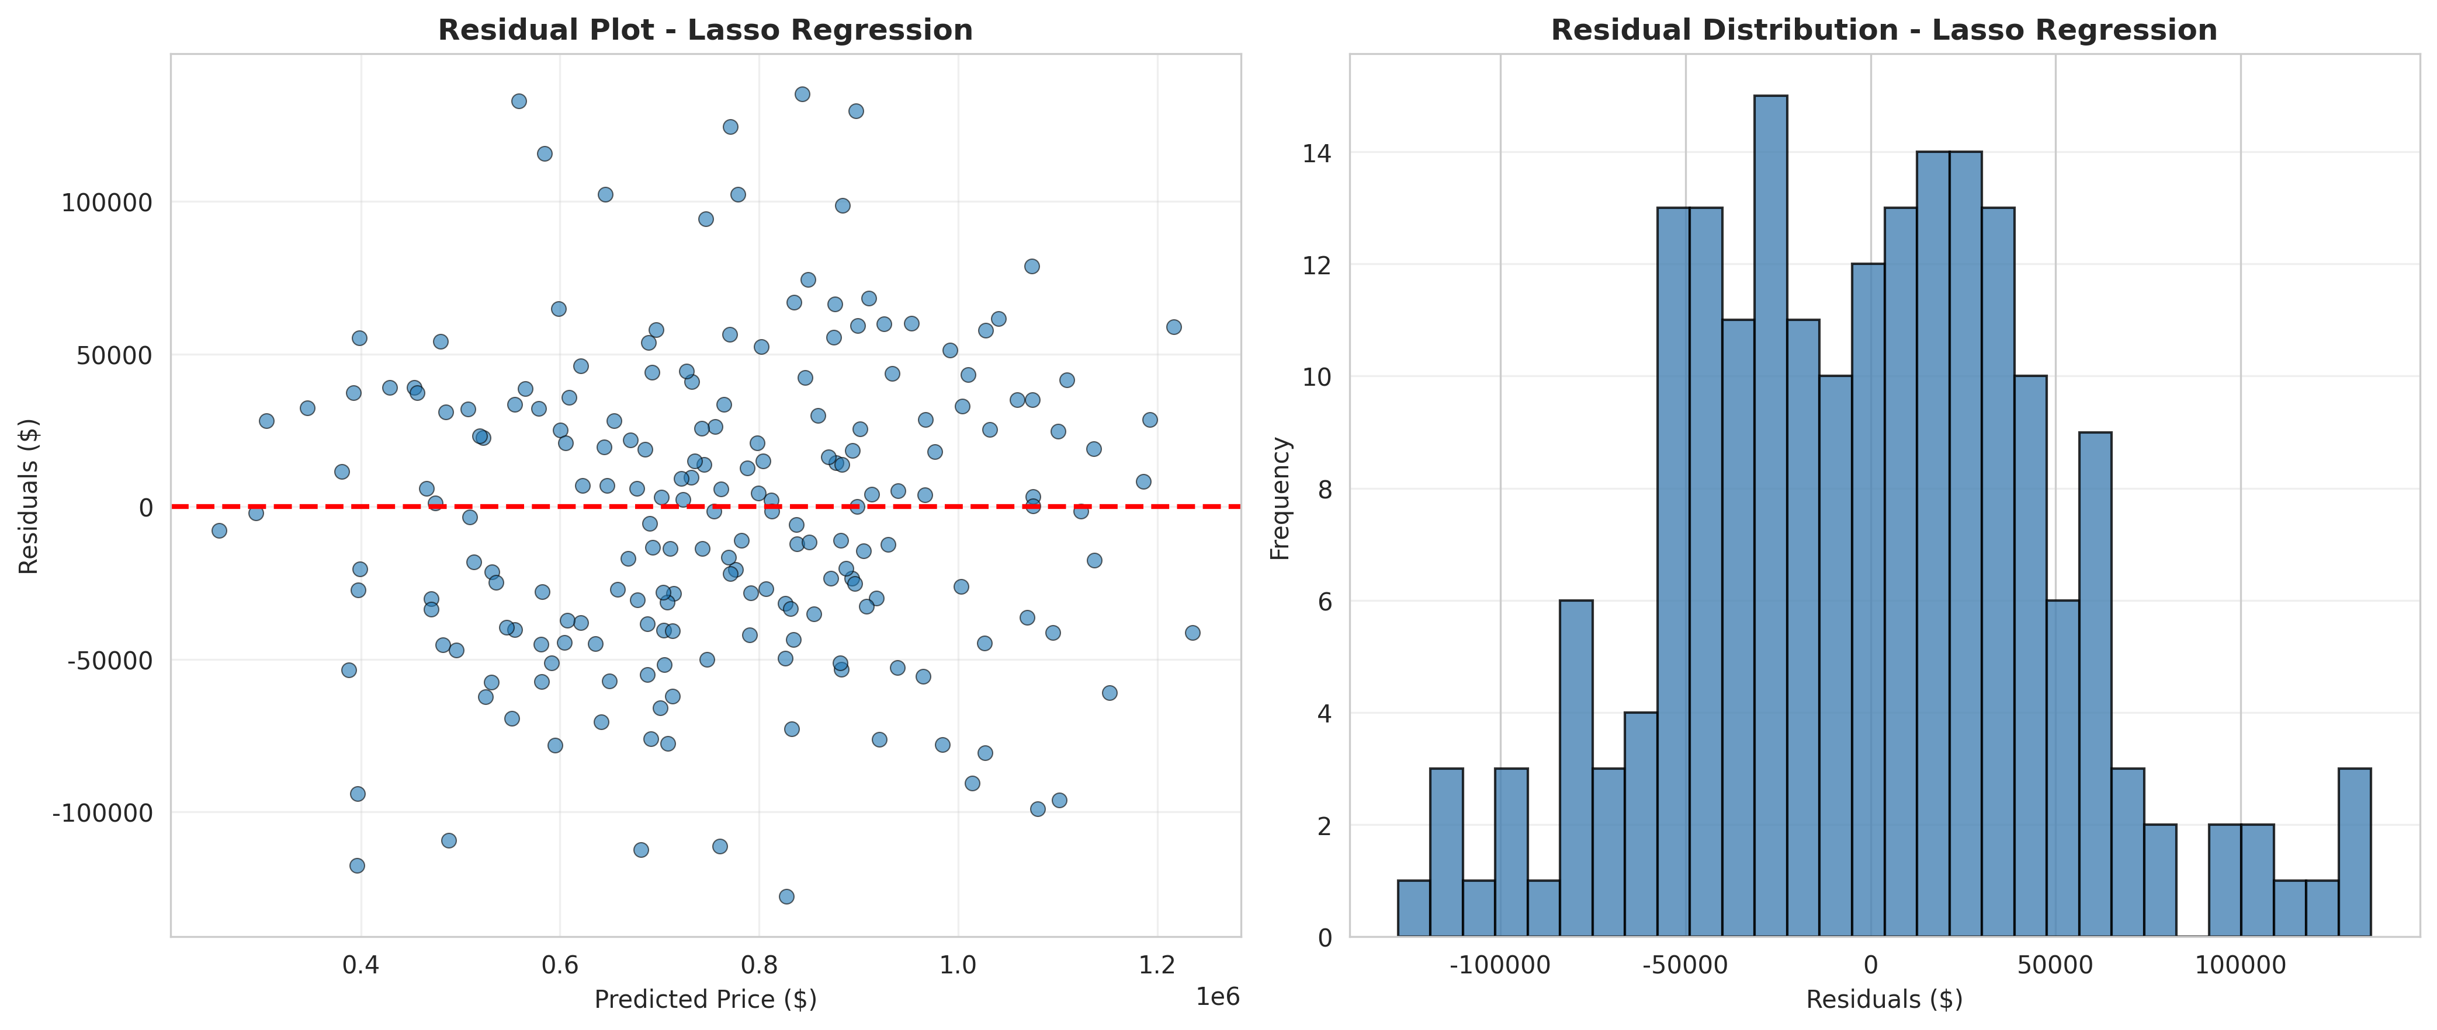
Figure 6: Residual Analysis for Lasso Regression
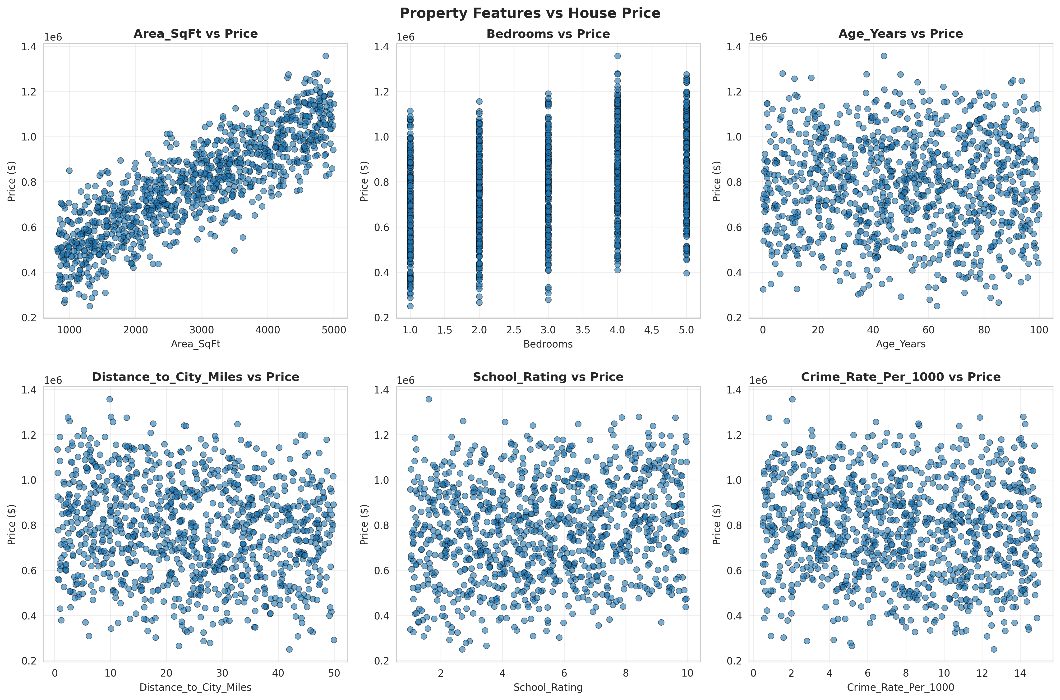
Figure 7: Property Features vs House Price
The comprehensive testing phase ensured that the feature engineering pipeline correctly extracted metrics and the models handled the scaled data appropriately. The robust performance metrics (under 6% MAPE) confirm that the solution meets the functional requirements established during the problem assessment phase, providing a highly accurate alternative to manual property valuation.
The comprehensive testing phase ensured that the feature engineering pipeline correctly extracted metrics and the models handled the scaled data appropriately. The robust performance metrics (under 6% MAPE) confirm that the solution meets the functional requirements established during the problem assessment phase, providing a highly accurate alternative to manual property valuation.

CHAPTER 6

CONCLUSION AND FUTURE SCOPE

6.1 Conclusion
The House Price Prediction System successfully addresses the critical challenge of determining accurate market values for residential properties. By integrating comprehensive feature engineering with robust machine learning regression algorithms, the system evaluates over 20 distinct attributes including structural dimensions, location intelligence, and property condition.
Through the rigorous development and testing process documented in this report, a predictive model utilizing Lasso Regression was established as the most effective estimator, achieving an R² score of 0.9453. The system provides a centralized methodology where real estate professionals can generate objective valuations backed by data rather than intuition. This project delivers a modern and intelligent valuation solution that improves pricing accuracy, supports data-driven real estate decisions, and enhances overall market transparency.

6.2 Future Scope
While the current system provides robust prediction capabilities, several enhancements could further increase its value to the real estate industry:
• Integration of Deep Learning architectures, specifically Neural Networks, to capture highly complex, non-linear relationships in massive nationwide property datasets.
• Implementation of geospatial analysis using GIS data to automatically calculate distances to specific amenities (parks, transit hubs) rather than relying on manual inputs.
• Development of a real-time API integration with MLS databases to dynamically update the model with the latest market sales data.
• Creation of a web-based dashboard allowing users to interactively adjust property features (e.g., "What if I add a pool?") to see the real-time impact on predicted value.
• Expansion of the system to include commercial real estate valuation, which requires analyzing different financial metrics such as cap rates and net operating income.

REFERENCES
[1] Pedregosa, F., et al. (2011). Scikit-learn: Machine Learning in Python. Journal of Machine Learning Research, 12, 2825-2830.
[2] McKinney, W. (2010). Data Structures for Statistical Computing in Python. Proceedings of the 9th Python in Science Conference, 51-56.
[3] Hunter, J. D. (2007). Matplotlib: A 2D graphics environment. Computing in Science & Engineering, 9(3), 90-95.
[4] Limsombunchai, V. (2004). House price prediction: hedonic price model vs. artificial neural network. New Zealand Agricultural and Resource Economics Society Conference.
[5] Park, B., & Bae, J. K. (2015). Using machine learning algorithms for housing price prediction: The case of Fairfax County, Virginia housing data. Expert Systems with Applications, 42(6), 2928-2934.
[6] Mayer, M., et al. (2019). Machine learning for real estate valuation. Journal of Property Investment & Finance, 37(1), 16-34.
[7] Council for Skills and Competencies (CSC India). (2025). Internship Guidelines and Organizational Overview.

